#### **Exercise 1: nslookup**

**Answer :**

1. Name: www.google.com  
   Address: 216.58.196.132  
     
   The IP address of google site: 216.58.196.132;

When I use other computer to nslookup www.google.com, it comes with address 216.58.200.100  
  
The reason of multiple output is that the busy websites like google usually replicate several servers, and this servers are running on different end system. These different end systems have different IP address. A set of IP addresses are associated with one hostname and so as to balance the serving load. The DNS requests with one of the IP addresses and the client connects to them, and the address may not always the same.

1. Name of 127.0.0.1: localhost; The address is the IP address of every computer, it is an internal interface for computer to send packet to itself instead of through the network, it can send message locally. TCP/IP uses the name “localhost” to represent the local machine.

#### **Exercise 2: Use ping to test host reachability**

**Answer :**

www.cse.unsw.edu.au reachable

www.getfittest.com.au unreachable

www.mit.edu reachable

www.intel.com.au reachable

www.tpg.com.au reachable

www.hola.hp unreachable

www.amazon.com reachable

www.tsinghua.edu.cn reachable

www.kremlin.ru reachable

8.8.8.8 reachable

www.getfittest.com.au and www.hola.hp are not reachable from web browser.  
Some hosts aren’t reachable because the domain names do not exist, or the network is down. And sometimes it is unreachable because they do not support ICMP protocol that is used by ping otherwise if many people use ping to request the server may collapse.

#### **Exercise 3: Use traceroute to understand network topology**

$*# traceroute www.columbia.edu*

*traceroute to www.wwwr53.cc.columbia.edu (128.59.105.24), 64 hops max, 52 byte packets*

*1 * * \**

*2 wfw1-ae-1-3062.gw.unsw.edu.au (129.94.254.172) 1.975 ms 2.070 ms 1.969 ms*

*3 libwdr1-vl-3063.gw.unsw.edu.au (129.94.254.178) 2.000 ms 2.205 ms 3.000 ms*

*4 ombcr1-te-4-5.gw.unsw.edu.au (149.171.255.77) 2.173 ms 4.727 ms 3.698 ms*

*5 unswbr1-te-2-13.gw.unsw.edu.au (149.171.255.105) 3.454 ms 2.440 ms 2.174 ms*

*6 138.44.5.0 (138.44.5.0) 2.334 ms 2.231 ms 2.164 ms*

*7 et-1-3-0.pe1.sxt.bkvl.nsw.aarnet.net.au (113.197.15.149) 3.340 ms 6.260 ms 4.185 ms*

*8 et-0-0-0.pe1.a.hnl.aarnet.net.au (113.197.15.99) 96.061 ms 96.327 ms 96.534 ms*

*9 et-2-1-0.bdr1.a.sea.aarnet.net.au (113.197.15.201) 219.442 ms 148.051 ms 149.431 ms*

*10 abilene-1-lo-jmb-706.sttlwa.pacificwave.net (207.231.240.8) 147.710 ms 147.413 ms 147.771 ms*

*11 et-4-0-0.4079.rtsw.miss2.net.internet2.edu (162.252.70.0) 158.384 ms 158.513 ms 158.878 ms*

*12 et-4-0-0.4079.rtsw.minn.net.internet2.edu (162.252.70.58) 181.461 ms 181.830 ms 183.558 ms*

*13 et-1-1-2.4079.rtsw.eqch.net.internet2.edu (162.252.70.106) 192.468 ms 285.851 ms 190.163 ms*

*14 ae-1.4079.rtsw.clev.net.internet2.edu (162.252.70.130) 228.359 ms 199.404 ms 293.249 ms*

*15 buf-9208-i2-clev.nysernet.net (199.109.11.33) 208.416 ms 300.928 ms 207.022 ms*

*16 syr-9208-buf-9208.nysernet.net (199.109.7.193) 213.950 ms 298.926 ms 206.607 ms*

*17 nyc-9208-syr-9208.nysernet.net (199.109.7.162) 219.170 ms 312.447 ms 313.695 ms*

*18 columbia.nyc-9208.nysernet.net (199.109.4.14) 419.980 ms 313.798 ms 311.762 ms*

*19 cc-core-1-x-nyser32-gw-1.net.columbia.edu (128.59.255.5) 315.990 ms 213.704 ms 307.109 ms*

*20 cc-conc-1-x-cc-core-1.net.columbia.edu (128.59.255.210) 314.123 ms 346.168 ms 307.458 ms*

*21 amistadresource.org (128.59.105.24) 318.678 ms 276.088 ms 314.665 ms*

**Answer :**

1. total: 21 routers; 4 routers are part of the UNSW network;

*8 et-0-0-0.pe1.a.hnl.aarnet.net.au (113.197.15.99) 96.061 ms 96.327 ms 96.534 ms*

*9 et-2-1-0.bdr1.a.sea.aarnet.net.au (113.197.15.201) 219.442 ms 148.051 ms 149.431 ms*  
Pacific Ocean:  
 The IP address between (*113.197.15.99*) and (*113.197.15.201*) cross the pacific Ocean cause the traceroute responses arrive more slowly. They firstly arrive at hnl-Honolulu and then arrive at sea-Seattle.

2.  
*$ traceroute www.ucla.edu*

*traceroute to gateway.lb.it.ucla.edu (164.67.228.152), 64 hops max, 52 byte packets*

*1 * * \**

*2 wfw1-ae-1-3062.gw.unsw.edu.au (129.94.254.172) 10.270 ms 3.035 ms 2.341 ms*

*3 libwdr1-vl-3063.gw.unsw.edu.au (129.94.254.178) 5.630 ms 3.625 ms 2.304 ms*

*4 libcr1-te-4-5.gw.unsw.edu.au (149.171.255.89) 3.649 ms 3.934 ms 2.229 ms*

*5 unswbr1-te-1-9.gw.unsw.edu.au (149.171.255.101) 2.711 ms 4.340 ms 5.661 ms*

*6 138.44.5.0 (138.44.5.0) 2.678 ms 6.714 ms 13.670 ms*

*7 et-1-3-0.pe1.sxt.bkvl.nsw.aarnet.net.au (113.197.15.149) 4.408 ms 4.264 ms 5.496 ms*

*8 et-0-0-0.pe1.a.hnl.aarnet.net.au (113.197.15.99) 97.853 ms 99.585 ms 99.438 ms*

*9 et-2-1-0.bdr1.a.sea.aarnet.net.au (113.197.15.201) 222.061 ms 154.421 ms 157.449 ms*

*10 cenichpr-1-is-jmb-778.snvaca.pacificwave.net (207.231.245.129) 214.732 ms 206.350 ms 212.142 ms*

*11 hpr-lax-hpr3--svl-hpr3-100ge.cenic.net (137.164.25.73) 200.454 ms 214.771 ms 203.413 ms*

*12 * * \**

*13 bd11f1.anderson--cr001.anderson.ucla.net (169.232.4.6) 245.856 ms 181.795 ms 266.412 ms*

*14 cr00f2.csb1--dr00f2.csb1.ucla.net (169.232.4.53) 278.946 ms*

*cr00f1.anderson--dr00f2.csb1.ucla.net (169.232.4.55) 220.545 ms 199.046 ms*

*15 * * \**

*16 * * \**

*17 * * \**

*18 * * \**

*19 * * \**

*20 * * \**

*21 * * \**

*22 * * \**

*23 * * \**

*24 * * \**

*25 * * \**

*26 * * \**

*27 * * \**

*28 * * \**

*29 * * \**

*30 * * \**

*31 * * \**

*32 * * \**

*33 * * \**

*34 * * \**

*35 * * \**

*36 * * \**

*37 * * \**

*38 * * \**

*39 * * \**

*40 * * \**

*41 * * \**

*42 * * \**

*43 * * \**

*44 * * \**

*45 * * \**

*46 * * \**

*47 * * \**

*48 * * \**

*49 * * \**

*50 * * \**

*51 * * \**

*52 * * \**

*53 * * \**

*54 * * \**

*55 * * \**

*56 * * \**

*57 * * \**

*58 * * \**

*59 * * \**

*60 * * \**

*61 * * \**

*62 * * \**

*63 * * \**

*64 * * \**

*$ traceroute www.u-tokyo.ac.jp*

*traceroute to www.u-tokyo.ac.jp (210.152.243.234), 64 hops max, 52 byte packets*

*1 * * \**

*2 wfw1-ae-1-3062.gw.unsw.edu.au (129.94.254.172) 2.725 ms 1.733 ms 1.497 ms*

*3 libwdr1-vl-3063.gw.unsw.edu.au (129.94.254.178) 2.871 ms 2.357 ms 3.706 ms*

*4 ombcr1-te-4-5.gw.unsw.edu.au (149.171.255.77) 1.926 ms 2.758 ms 1.952 ms*

*5 unswbr1-te-2-13.gw.unsw.edu.au (149.171.255.105) 2.059 ms 2.326 ms 2.703 ms*

*6 138.44.5.0 (138.44.5.0) 2.328 ms 2.027 ms 2.141 ms*

*7 et-0-3-0.pe1.bkvl.nsw.aarnet.net.au (113.197.15.147) 4.325 ms 2.890 ms 2.830 ms*

*8 ge-4_0_0.bb1.a.pao.aarnet.net.au (202.158.194.177) 235.232 ms 157.295 ms 256.297 ms*

*9 paloalto0.iij.net (198.32.176.24) 202.820 ms 207.739 ms 225.517 ms*

*10 osk004bb00.iij.net (58.138.88.185) 296.723 ms 265.306 ms 266.691 ms*

*11 osk004ix51.iij.net (58.138.106.130) 303.279 ms*

*osk004ix51.iij.net (58.138.106.126) 286.594 ms*

*osk004ix51.iij.net (58.138.106.130) 268.049 ms*

*12 210.130.135.130 (210.130.135.130) 357.443 ms 272.552 ms 352.626 ms*

*13 124.83.228.78 (124.83.228.78) 313.468 ms 268.172 ms 358.254 ms*

*14 124.83.252.250 (124.83.252.250) 313.317 ms 272.606 ms 274.635 ms*

*15 158.205.134.26 (158.205.134.26) 329.242 ms 274.657 ms 283.867 ms*

*16 * * \**

*17 * * \**

*18 * * \**

*19 * * \**

*20 * * \**

*21 * * \**

*22 * * \**

*23 * * \**

*24 * * \**

*25 * * \**

*26 * * \**

*27 * * \**

*28 * * \**

*29 * * \**

*30 * * \**

*31 * * \**

*32 * * \**

*33 * * \**

*34 * * \**

*35 * * \**

*36 * * \**

*37 * * \**

*38 * * \**

*39 * * \**

*40 * * \**

*41 * * \**

*42 * * \**

*43 * * \**

*44 * * \**

*45 * * \**

*46 * * \**

*47 * * \**

*48 * * \**

*49 * * \**

*50 * * \**

*51 * * \**

*52 * * \**

*53 * * \**

*54 * * \**

*55 * * \**

*56 * * \**

*57 * * \**

*58 * * \**

*59 * * \**

*60 * * \**

*61 * * \**

*62 * * \**

*63 * * \**

*64 * * \**

*$ trace www.lancaster.ac.uk*

*traceroute to www.lancaster.ac.uk (148.88.65.80), 64 hops max, 52 byte packets*

*1 * * \**

*2 wfw1-ae-1-3062.gw.unsw.edu.au (129.94.254.172) 3.476 ms 2.056 ms 1.758 ms*

*3 libwdr1-vl-3063.gw.unsw.edu.au (129.94.254.178) 3.710 ms 2.921 ms 4.342 ms*

*4 libcr1-te-4-5.gw.unsw.edu.au (149.171.255.89) 2.162 ms 2.019 ms 2.032 ms*

*5 unswbr1-te-1-9.gw.unsw.edu.au (149.171.255.101) 1.903 ms 2.043 ms 2.004 ms*

*6 138.44.5.0 (138.44.5.0) 2.403 ms 2.043 ms 2.171 ms*

*7 et-1-3-0.pe1.sxt.bkvl.nsw.aarnet.net.au (113.197.15.149) 3.077 ms 3.197 ms 3.413 ms*

*8 et-0-0-0.pe1.a.hnl.aarnet.net.au (113.197.15.99) 96.909 ms 97.326 ms 96.102 ms*

*9 et-2-1-0.bdr1.a.sea.aarnet.net.au (113.197.15.201) 148.569 ms 147.109 ms 183.106 ms*

*10 abilene-1-lo-jmb-706.sttlwa.pacificwave.net (207.231.240.8) 147.482 ms 205.086 ms 147.888 ms*

*11 et-4-0-0.4079.rtsw.miss2.net.internet2.edu (162.252.70.0) 167.004 ms 205.945 ms 209.445 ms*

*12 et-4-0-0.4079.rtsw.minn.net.internet2.edu (162.252.70.58) 207.969 ms 209.807 ms 215.272 ms*

*13 et-1-1-2.4079.rtsw.eqch.net.internet2.edu (162.252.70.106) 202.411 ms 210.696 ms 206.652 ms*

*14 ae-1.4079.rtsw.clev.net.internet2.edu (162.252.70.130) 214.837 ms 202.306 ms 221.634 ms*

*15 et-2-0-0.4079.rtsw.ashb.net.internet2.edu (162.252.70.54) 300.664 ms 313.400 ms 211.078 ms*

*16 ae-2.4079.rtsw.wash.net.internet2.edu (162.252.70.136) 309.423 ms 388.157 ms 254.261 ms*

*17 internet2.mx1.lon.uk.geant.net (62.40.124.44) 373.451 ms 288.454 ms 309.571 ms*

*18 janet-gw.mx1.lon.uk.geant.net (62.40.124.198) 313.707 ms 388.618 ms 316.655 ms*

*19 ae29.londpg-sbr2.ja.net (146.97.33.2) 312.106 ms 366.932 ms 286.406 ms*

*20 ae31.erdiss-sbr2.ja.net (146.97.33.22) 284.776 ms 310.879 ms 314.846 ms*

*21 ae29.manckh-sbr2.ja.net (146.97.33.42) 286.731 ms 313.740 ms 312.610 ms*

*22 ae24.lanclu-rbr1.ja.net (146.97.38.58) 312.724 ms 417.816 ms 315.102 ms*

*23 * lancaster-university.ja.net (194.81.46.2) 320.840 ms \**

*24 ismx-issrx.rtr.lancs.ac.uk (148.88.255.17) 291.751 ms 374.975 ms 291.724 ms*

*25 dc.iss.srv.rtrcloud.lancs.ac.uk (148.88.253.3) 332.691 ms 311.265 ms 417.494 ms*

*26 www.lancs.ac.uk (148.88.65.80) 291.543 ms !Z 379.853 ms !Z 314.374 ms !Z*

From the router 138.44.5.0 these three destinations diverge;

Name: www.ucla.edu

Address: 164.67.228.152

Total router: 13

Distance: 7499.0 miles

Name: www.u-tokyo.ac.jp

Address: 210.152.243.234

Total router: 15

Distance: 4908.7 miles

Name: www.lancaster.ac.uk

Address: 148.88.65.80

Total router: 26

Distance: 10569.8 miles

So the number of hops on each path is not proportional the physical distance.

3. Traceroute to 129.94.8.22 :

*1 gigabitethernet3-3.exi2.melbourne.telstra.net (203.50.77.53) 0.287 ms 0.222 ms 0.245 ms*

*2 bundle-ether3-100.win-core10.melbourne.telstra.net (203.50.80.129) 1.119 ms 1.487 ms 2.119 ms*

*3 bundle-ether12.ken-core10.sydney.telstra.net (203.50.11.122) 13.488 ms 12.107 ms 12.862 ms*

*4 bundle-ether1.ken-edge901.sydney.telstra.net (203.50.11.95) 11.987 ms 11.732 ms 11.863 ms*

*5 aarnet6.lnk.telstra.net (139.130.0.78) 11.613 ms 11.609 ms 11.612 ms*

*6 ge-6-0-0.bb1.a.syd.aarnet.net.au (202.158.202.17) 11.862 ms 11.731 ms 11.738 ms*

*7 ae9.pe2.brwy.nsw.aarnet.net.au (113.197.15.56) 12.112 ms 12.232 ms 31.851 ms*

*8 et-3-1-0.pe1.brwy.nsw.aarnet.net.au (113.197.15.146) 12.363 ms 12.357 ms 12.363 ms*

*9 138.44.5.1 (138.44.5.1) 12.613 ms 12.607 ms 12.614 ms*

*10 ombcr1-te-1-5.gw.unsw.edu.au (149.171.255.106) 12.612 ms 12.607 ms 12.612 ms*

*11 libwdr1-te-1-2.gw.unsw.edu.au (149.171.255.78) 12.613 ms 12.607 ms 12.604 ms*

*12 wfw1-ae-1-3063.gw.unsw.edu.au (129.94.254.180) 13.110 ms 13.105 ms 13.112 ms*

*13 libwdr1-vl-3063.gw.unsw.edu.au (129.94.254.178) 12.988 ms 13.105 ms 13.113 ms*

*14 wfw1-ae-1-3063.gw.unsw.edu.au (129.94.254.180) 13.362 ms 13.356 ms 13.238 ms*

*15 libwdr1-vl-3063.gw.unsw.edu.au (129.94.254.178) 13.363 ms 13.356 ms 13.363 ms*

*16 wfw1-ae-1-3063.gw.unsw.edu.au (129.94.254.180) 13.487 ms 13.481 ms 13.612 ms*

*17 libwdr1-vl-3063.gw.unsw.edu.au (129.94.254.178) 13.487 ms 13.480 ms 13.613 ms*

*18 wfw1-ae-1-3063.gw.unsw.edu.au (129.94.254.180) 14.861 ms 14.855 ms 14.862 ms*

*19 libwdr1-vl-3063.gw.unsw.edu.au (129.94.254.178) 14.737 ms 14.854 ms 14.862 ms*

Traceroute to www.telstra.net :

*traceroute to www.telstra.net (203.50.5.178), 64 hops max, 52 byte packets*

*1 * * \**

*2 wfw1-ae-1-3062.gw.unsw.edu.au (129.94.254.172) 5.168 ms 2.659 ms 2.507 ms*

*3 libwdr1-vl-3063.gw.unsw.edu.au (129.94.254.178) 2.685 ms 3.873 ms 3.150 ms*

*4 ombcr1-te-4-5.gw.unsw.edu.au (149.171.255.77) 2.765 ms 2.306 ms 3.327 ms*

*5 unswbr1-te-2-13.gw.unsw.edu.au (149.171.255.105) 32.023 ms 2.234 ms 2.076 ms*

*6 138.44.5.0 (138.44.5.0) 2.343 ms 2.625 ms 2.489 ms*

*7 et-0-3-0.pe1.bkvl.nsw.aarnet.net.au (113.197.15.147) 2.883 ms 3.095 ms 3.577 ms*

*8 ae9.bb1.a.syd.aarnet.net.au (113.197.15.57) 3.048 ms 3.724 ms 3.591 ms*

*9 gigabitethernet1-1.pe1.b.syd.aarnet.net.au (202.158.202.18) 5.299 ms 3.266 ms 3.195 ms*

*10 gigabitethernet3-11.ken37.sydney.telstra.net (139.130.0.77) 4.110 ms 5.272 ms 3.749 ms*

*11 bundle-ether13.ken-core10.sydney.telstra.net (203.50.11.94) 5.934 ms 4.916 ms 5.289 ms*

*12 bundle-ether10.win-core10.melbourne.telstra.net (203.50.11.123) 16.634 ms 16.920 ms 16.637 ms*

*13 gigabitethernet5-0.exi-service2.melbourne.telstra.net (203.50.80.132) 14.968 ms 14.639 ms 14.707 ms*

*14 * * \**

*15 * * \**

*16 * * \**

*17 * * \**

*18 * * \**

*19 * * \**

*20 * * \**

*21 * * \**

*22 * * \**

*23 * * \**

*24 * * \**

*25 * * \**

*26 * * \**

*27 * * \**

*28 * * \**

*29 * * \**

*30 * * \**

*31 * * \**

*32 * * \**

*33 * * \**

*34 * * \**

*35 * * \**

*36 * * \**

*37 * * \**

*38 * * \**

*39 * * \**

*40 * * \**

*41 * * \**

*42 * * \**

*43 * * \**

*44 * * \**

*45 * * \**

*46 * * \**

*47 * * \**

*48 * * \**

*49 * * \**

*50 * * \**

*51 * * \**

*52 * * \**

*53 * * \**

*54 * * \**

*55 * * \**

*56 * * \**

*57 * * \**

*58 * * \**

*59 * * \**

*60 * * \**

*61 * * \**

*62 * * \**

*63 * * \**

*64 * * \**

I choose IP address 129.94.8.22;

So the trace route of the reverse path has different routers as the forward path.

Yes, the router *17 libwdr1-vl-3063.gw.unsw.edu.au (129.94.254.178)* is same both in reverse path and forward path, but actually sometimes it is different because the path chosen is randomly.

#### **Exercise 4: Use ping to gain insights into network performance**

**Answer :**

www.uq.edu.au

www.uq.edu.au_delay.pdf :

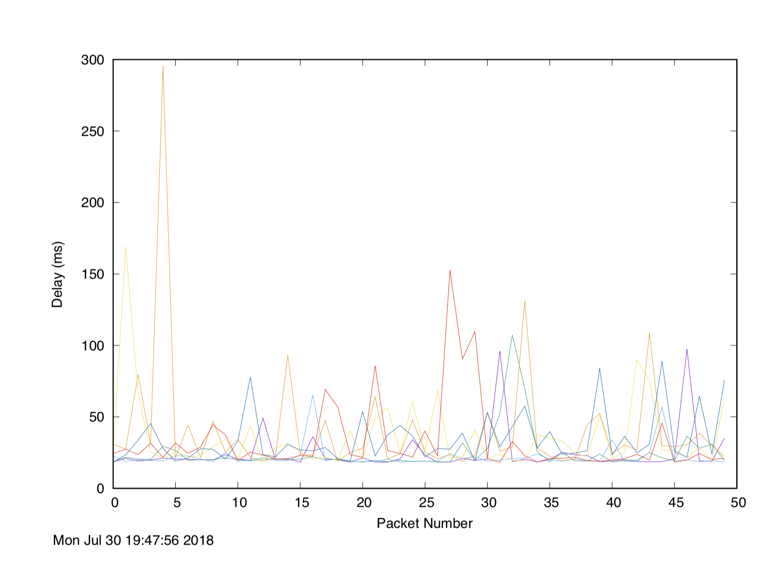

www.uq.edu.au_scatter.pdf :

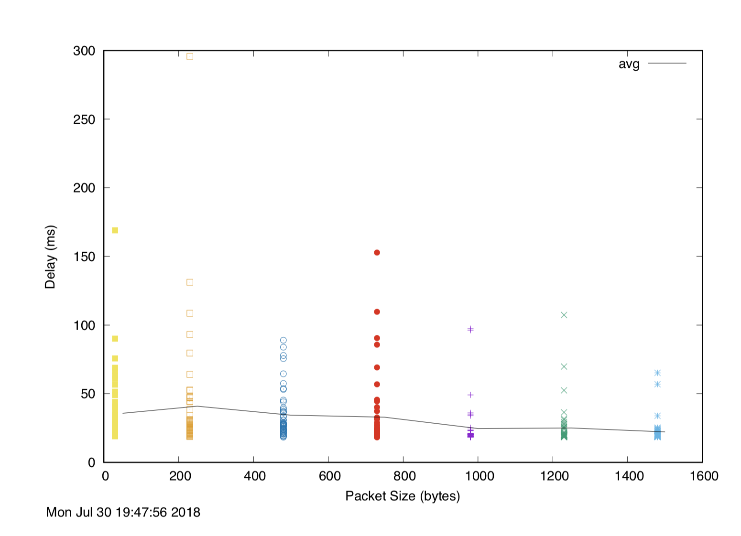

www.uq.edu.au_avg.txt :

*50 35.776 19.001*

*250 40.923 18.762*

*500 34.403 18.366*

*750 32.899 18.220*

*1000 24.641 18.289*

*1250 25.024 18.384*

*1500 22.196 18.469*

www.nus.edu.sg

www.nus.edu.sg_delay.pdf :

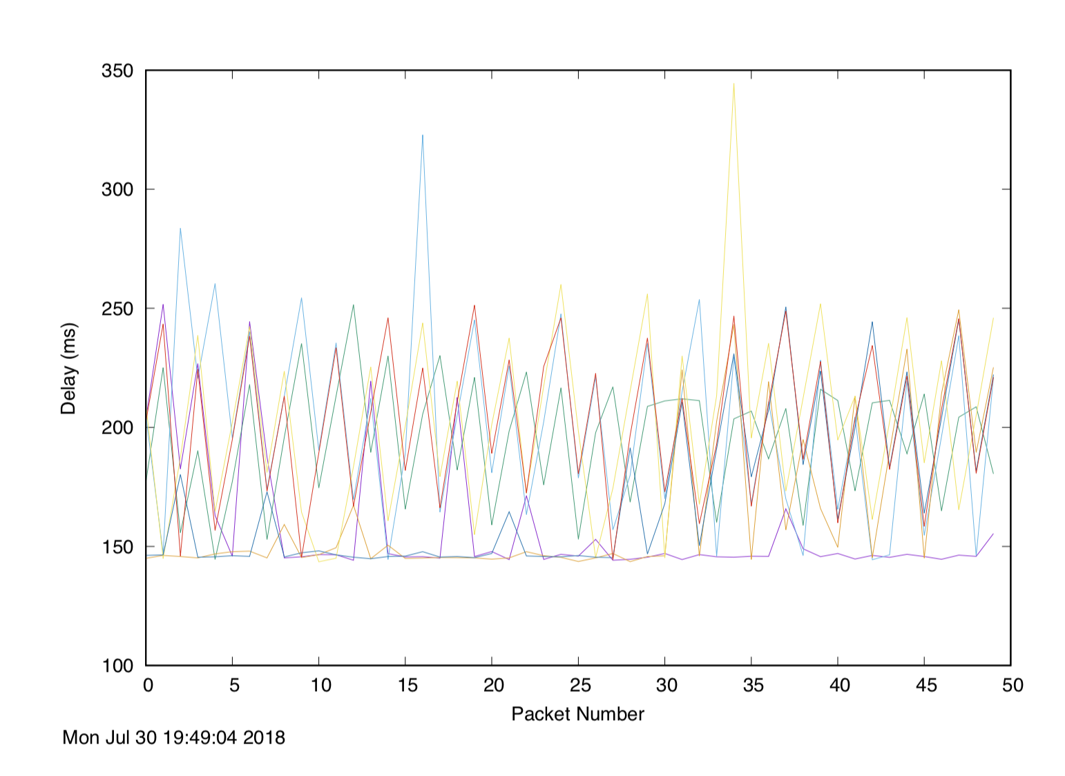

www.nus.edu.sg_delay.pdf :

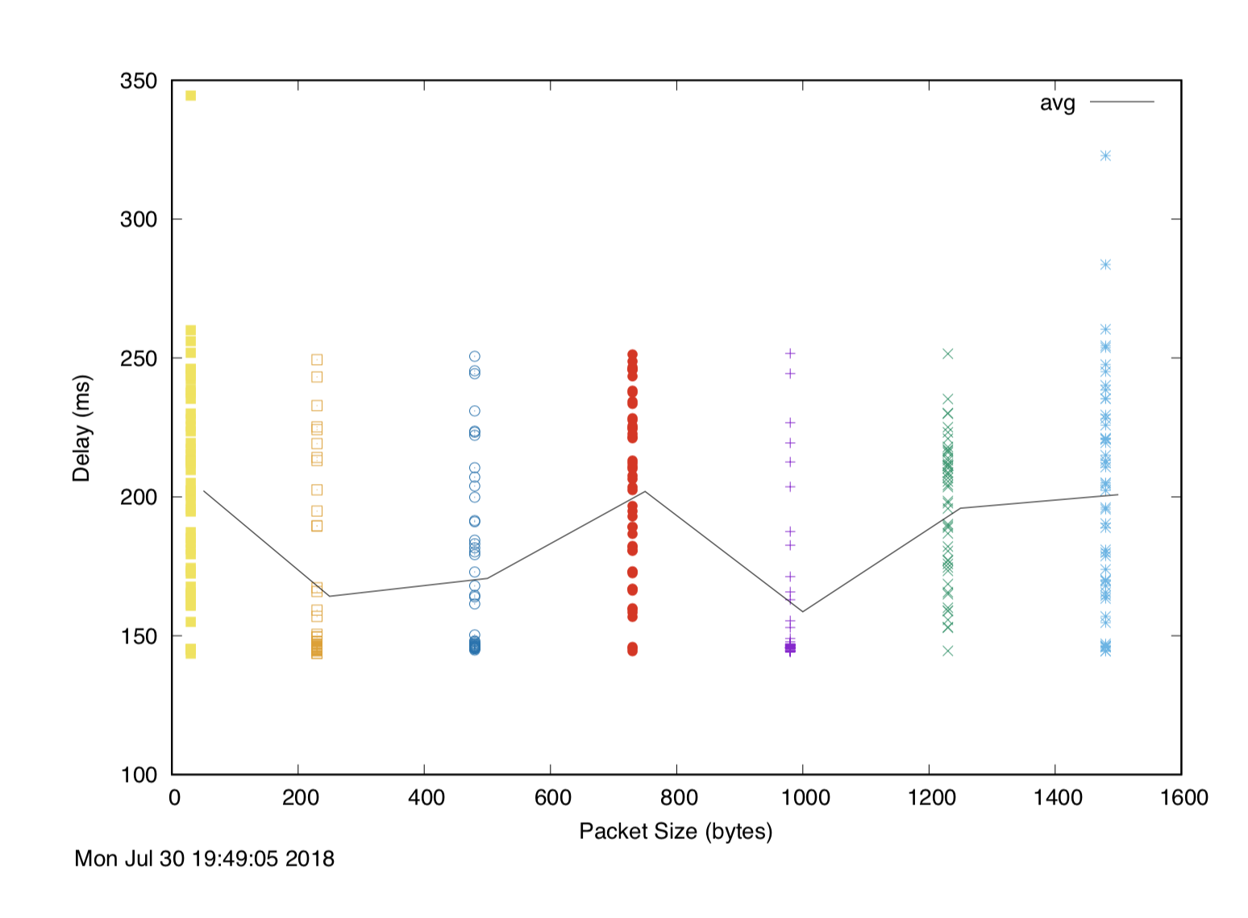

www.nus.edu.sg_avg.txt :

*50 202.180 143.563*

*250 164.209 143.627*

*500 170.631 144.855*

*750 201.959 144.448*

*1000 158.636 144.177*

*1250 195.903 144.536*

*1500 200.764 144.449*

www.tu-berlin.de:

www.tu-berlin.de_delay.pdf :

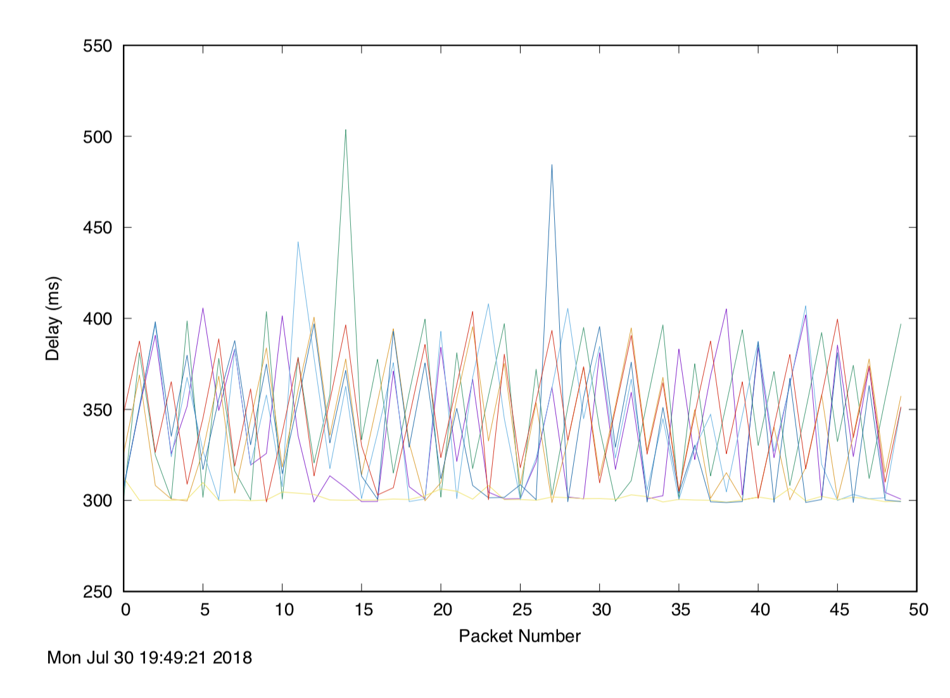

www.tu-berlin.de_scatter.pdf :

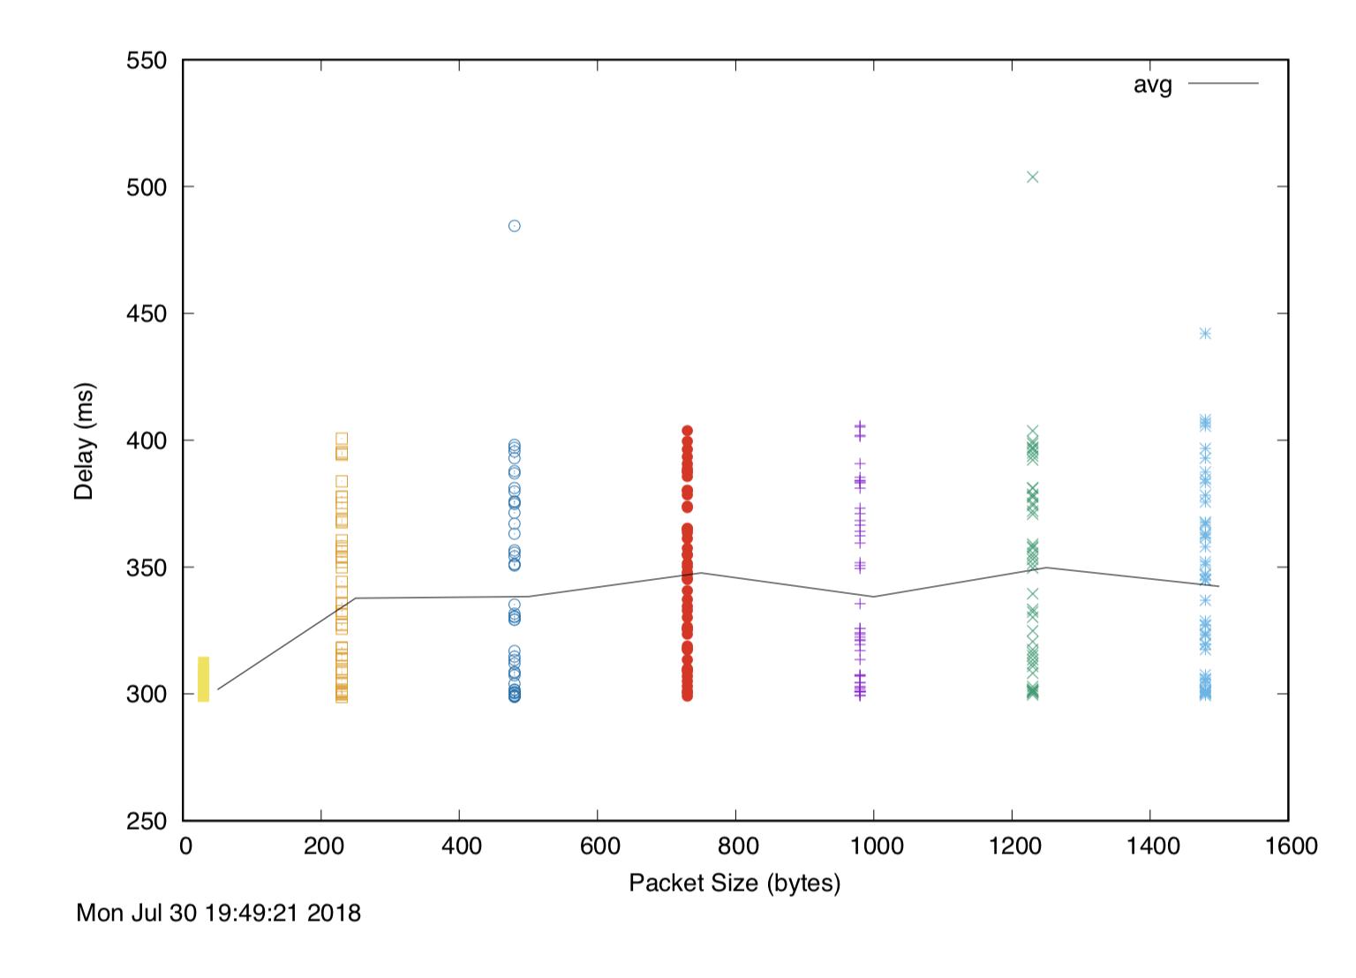

www.tu-berlin.de_avg.txt :

*50 301.720 299.052*

*250 337.760 298.777*

*500 338.404 298.848*

*750 347.670 299.100*

*1000 338.313 299.256*

*1250 349.814 299.714*

*1500 342.440 299.441*

1. distance:

unsw to www.uq.edu.au : 735 miles 2.45ms

unsw to www.tu-berlin.de : 6332 miles 21.1ms

unsw to www.tu-berlin.de : 16154 miles 53.84ms

y-axis : the ratio between the minimum delay

19.001/2.45=7.755

143.563/21.1=6.803

299.052/53.84=5.554

First, there are different kinds of influence like physical factors, hardware factors or other factors to cause the delays during transmission.

Second, the transition speed is not as fast as light speed, it costs longer to get to destination.

Third, the transition is a round trip which will cost double time to go and back.

1. Beacuse of the difference between packets switching, the delay to the destination vary over time.
2. Transmission delay and queueing delay depend on packet size.

Propagation delay and processing delay don’t depend on packet size.